Bahria University,

Karachi Campus



LAB EXPERIMENT NO.

**05**

LIST OF TASKS

|  |  |
| --- | --- |
| TASK NO | OBJECTIVE |
| 1 | **While utilizing the Linux commands studied so far, provide an example (other than the one shown in this Lab) of a combination of several Linux commands in which pipes are used more than once. Also provide a snapshot of the generated output.** |
| 2 | **Write C program to print all alphabets from a to z using while loop.(using ASCII)** |
| 3 | **Write a shell script that records the full path of all the files present within a directory into a record.txt file. Along with full path name, the script should also record the number of words, characters and lines within each file** |
| 4 | **Write a C program that asks the user to provide an integer input in the main() function. The program would call a function even_odd() from the main() function, where the function even_odd() accepts an integer as an argument, determine and display if the passed integer is either even or odd** |
|  |  |

Submitted On:

**-May-2022**

**Task No. 1: While utilizing the Linux commands studied so far, provide an example *(other than the one shown in this Lab)* of a combination of several Linux commands in which pipes are used more than once. Also provide a snapshot of the generated output.**

**Solution: & OUTPUT**:

**Task No. 2: Write C program to print all alphabets from a to z using while loop.(using ASCII)**

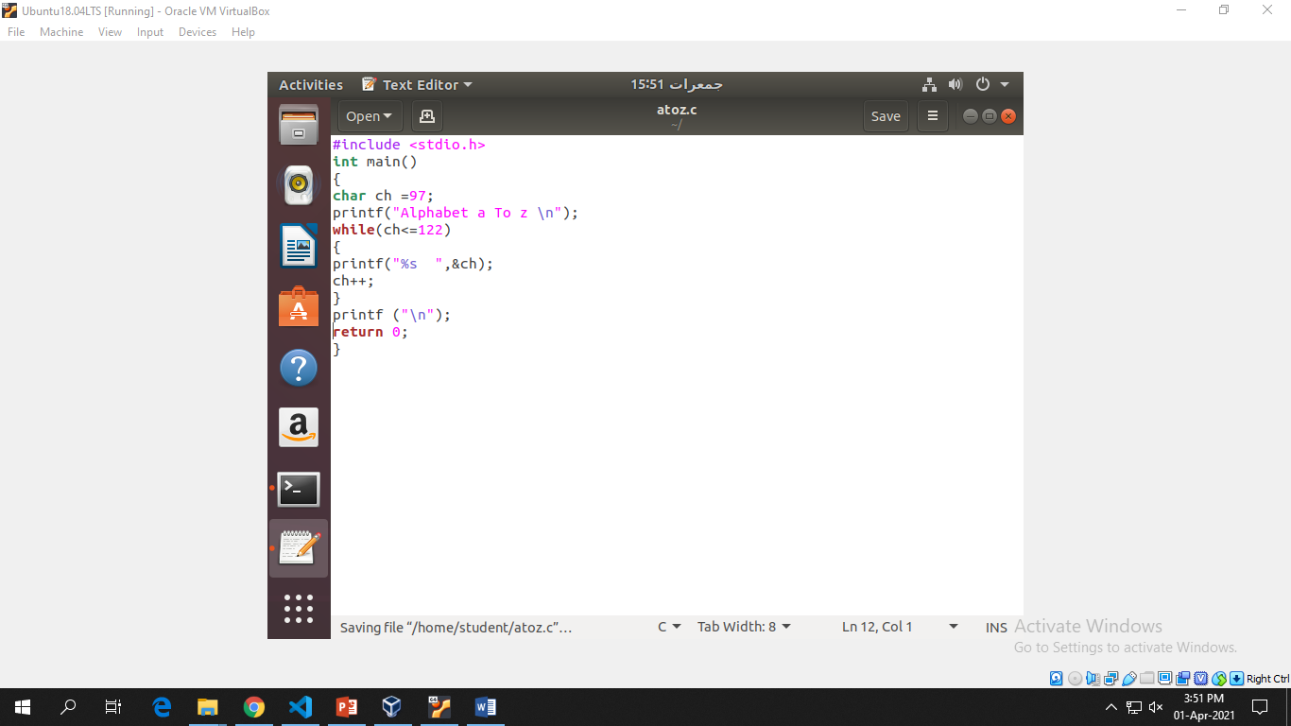**Solution: & OUTPUT:**

**Task No. 3: Write a shell script that records the full path of all the files present within a directory into a record.txt file. Along with full path name, the script should also record the number of words, characters and lines within each file**

**Solution: & OUTPUT**:

**Task No. 4: Write a C program that asks the user to provide an integer input in the main() function. The program would call a function even_odd() from the main() function, where the function even_odd() accepts an integer as an argument, determine and display if the passed integer is either even or odd**

**Solution: & OUTPUT**:

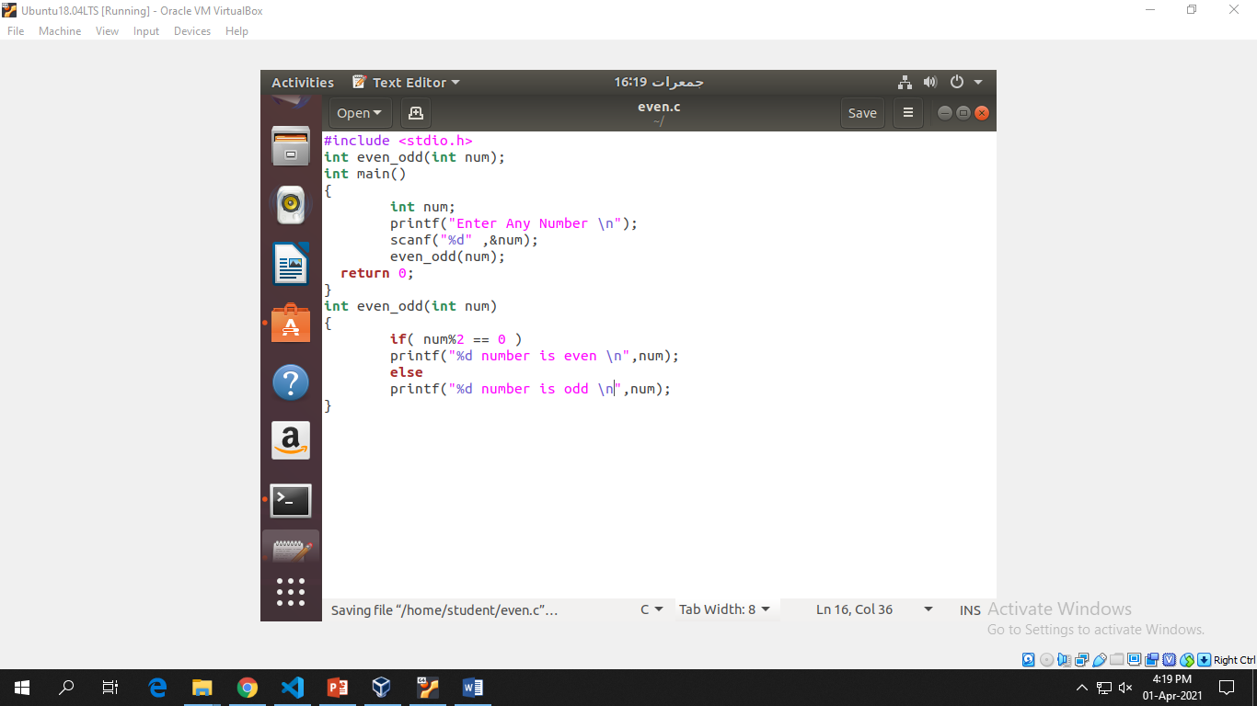

Bahria University,

Karachi Campus

LAB EXPERIMENT NO.

**06**

LIST OF TASKS

|  |  |
| --- | --- |
| TASK NO | OBJECTIVE |
| 1 | **Write what you have learned in few lines on each of the three programs that were using the fork() system call** |
| 2 | **Write a C program that uses fork() system call to print a single line eight times without using for loop and repeated printf command** |
| 3 | **Code the C program given below and explain what it does along with providing a snapshot of the output. Investigate and write about the usage of execlp() system call.** |
| 4 | **Write a program to declare a counter variable initialized by zero. After fork() system call two processes will run in parallel both incrementing their own version of counter and print numbers 1 -5 . After printing numbers child process will sleep for three second, then print process id of its grandparent and terminates by invoking a gedit editor. Meanwhile, its parent waits for its termination.** |
|  |  |

Submitted On:

**-May-202**

**Task No. 1: Write what you have learned in few lines on each of the three programs that were using the *fork()* system call**

**Solution: & OUTPUT:**

## Program 1:-

int main() {  
printf(“before forking \n”); fork();  
printf(“after forking \n”); return 0;}

## Program 2: -

int i = 5;  
void parent_process();   
void child_process(); int main() {  
pid_t pid; pid = fork(); if(pid == 0) {

i += 10;  
child_process();}

else {parent_process();}  
return 0;}  
void parent_process() {  
printf("I am a parent process and my value of 'i' is %d \n",i);}  
void child_process() {  
printf("I am a child process and my value of 'i' is %d \n",i);}



## Program 3: -

int main (){  
fork();  
fork();  
printf("hello world \n"); return 0;}

## Program 4: -

int main(){  
pid_t pid; pid = fork(); if(pid == 0){  
printf("I am child and my parent is %d and my own PID is %d\n", getppid(), getpid());}  
else if(pid > 0){  
printf("I am a Parent and my pid is %d\n", getpid());}  
return 0;}



**Task No. 2: Write a C program that uses fork() system call to print a single line eight times without using for loop and repeated printf command**

**Solution: & OUTPUT:**

**Task No. 3: Code the C program given below and explain what it does along with providing a snapshot of the output. Investigate and write about the usage of execlp() system call.**

**Solution: & OUTPUT:**

**Task No. 4: Write a program to declare a counter variable initialized by zero. After fork() system call two processes will run in parallel both incrementing their own version of counter and print numbers 1 -5 . After printing numbers child process will sleep for three second, then print process id of its grandparent and terminates by invoking a gedit editor. Meanwhile, its parent waits for its termination.**

**Solution: & Output**:

int counter_parent = 0,counter_child = 0; int main(){

pid_t pid = fork(); if (pid > 0) {

printf("Parent Process starting\n"); for(int i = 1;i<6;i++) {

counter_parent += 5; printf("%d\n",i);}}

else if(pid == 0) {

printf("Child Process starting\n"); for(int i = 1;i<6;i++) {

counter_child += 10; printf("%d\n",i);}

sleep(3);

printf("The process id of the parent process is %d",getppid()); execlp("/bin/gedit","gedit",NULL);}}

